
TRACKIFY: PERSONAL BUDGET TRACKER MOBILE APP

Capstone Project Presented to
CEDAR College, Inc.
National Highway
Cadiz City, Negros Occidental

In Partial Fulfillment of the
Requirements for the Degree of
Bachelor of Science in Information Technology

Aireen F. Deocampo
John Philip M. Villa
Nel Mayer M. Tibor
Yasmin A. Pescadero

March 2025

APPROVAL SHEET

This Capstone Project

TRACKIFY: PERSONAL BUDGET TRACKER MOBILE APP
Prepared and submitted by Aireen Deocampo, Yasmin Pescadero, Nel Mayer Tibor, John Philip Villa,is hereby recommended for approval and acceptance as requirements for the degree:

Bachelor of Science in Information Technology

JOHN DAVE BARILEA
Capstone Adviser

Acceptance by the panel of Evaluators with a grade of __________.
PANEL OF EVALUATORS

WILFREDO C. VILLANUEVA, PhD.
Lead Panel

ROMEO D. LOBATON, JR. JOHN PAUL B. PALMA
Panelist Panelist

Approved as required for the degree of Bachelor of Science in Information Technology

WILFREDO C. VILLANUEVA, PhD.

School President
ACKNOWLEDGMENT

We would like to express our sincere gratitude to everyone who has supported us throughout this capstone project, which has been a meaningful endeavor for us. We would like to express our sincere appreciation to our capstone advisor, MR. JOHN DAVE BARILEA, for his exceptional guidance, unrelenting patience, and continuous motivation throughout the project.

We would also like to extend our gratitude to our school president, WILFREDO C. VILLANUEVA, PhD., the panel members, ROMEO D. LOBATON, JR., and JOHN PAUL B. PALMA, for their time and efforts in providing us with invaluable feedback and suggestions and for their constructive criticism and insightful feedback that have significantly contributed to the enhancement of our project.

We would also like to acknowledge our fellow students and faculty members for their invaluable support, suggestions, and critiques. Their insightful feedback and willingness to help us whenever we needed it have been crucial to our success.

Furthermore, we would like to extend our appreciation to our families and friends, who have been a constant source of motivation and encouragement. Their unwavering support and belief in us have been instrumental in keeping us focused on our goals.

Finally, we would like to thank each other for the hard work, dedication, and teamwork that have led to the successful completion of this capstone project. To all those who have played a role in our journey, thank you for your support and encouragement. We could not have done it without you.
ABSTRACT

This study aimed to design and develop Trackify: Personal Budget Tracker Mobile App, a finance tracking application designed to help individuals effectively manage their personal finances. The system enables users to monitor their income, expenses, and savings, providing insights into their financial health. By offering features such as budget planning, expense categorization, and financial goal tracking, the application aims to promote better financial management habits.
The system generates reports and financial summaries quickly and accurately, allowing users to gain a clear understanding of their spending patterns. To evaluate the system’s effectiveness, the System Usability Scale (SUS) was used to assess its usability, efficiency, and overall user experience. The results of the evaluation indicated that the system meets usability standards, ensuring that users can navigate and utilize its features with ease.
The study also aimed to identify the benefits of Trackify in improving financial awareness and budgeting practices. Respondents for this project included individuals from Victorias City and Cadiz City, with varying financial habits and challenges. The system provides a solution for users who struggle with tracking their finances manually or lack a structured budgeting system.
Users confirmed that before using the application, they had difficulties in managing their expenses and maintaining financial discipline. However, after using Trackify, they found it easier to monitor their spending, set financial goals, and make informed financial decisions. Overall, the Trackify: Personal Budget Tracker Mobile App provides an efficient and effective tool for individuals looking to enhance their financial literacy and maintain control over their finances.
Keywords:
Finance Tracker, Budgeting, System Usability Scale (SUS), Personal Finance Management

TABLE OF CONTENTS

Title

Title Page i
Approval Sheet ii
Acknowledgement iii
Abstract iv
Table of Contents v
List of Tables vii
List of Figures viii

CHAPTER I
Introduction 1
Project Context 1
Project Description 1
Objectives 2
Significance of the Study 2
Scope and Limitation 4
Definition of Terms 4
Review of Related Literature 8
Conceptual Framework 14

CHAPTER II
Research Design 15
Locale of the Study 15
Theoretical Framework 18
Use Case Diagram 21
Requirements Cost 22
Gantt Chart 24
System Prototype 25
Data Flow Diagram 26
ER Diagram 27
System Architecture 27
Program Evaluation and Review Technique 29
Critical Path Method 29
Cost Benefits Analysis 30

CHAPTER III
Presentation of Data 32
Projections 42

CHAPTER IV
Conclusion 45
Recommendations 46
References 48
List of Tables

No.
- Requirements Cost 22
- Hardware Requirements 22
- Software Requirements 23
- Network Requirements 23
- Integration Requirements 23
- Gantt Chart 24
- Cost Benefits Analysis 30
- Presentation of Data 32
List of Figures

No.
- Conceptual Framework 13
- Locale of the Study 16
- Theoretical Framework 18
- Use Case Diagram 21
- System Prototype 25
- Data Flow Diagram Level 0 26
- ER Diagram 27
- System Architecture 28
- Program Evaluation and Review Technique 29
10. Critical Path Method 29
CHAPTER I
INTRODUCTION
Project Context
In the modern world, personal financial management has become increasingly challenging due to the rising cost of living, inflation, and the complexity of financial decisions. Many individuals struggle to keep track of their income, expenses, and savings, often leading to impulsive spending and poor financial habits. The need for effective financial management tools has never been more important, as people seek ways to better organize their finances, achieve savings goals, and make informed financial decisions.
Despite the availability of numerous digital financial services, many people still face difficulties in accessing, understanding, and utilizing these tools to their full potential. This gap in financial literacy and access to user-friendly financial management systems presents a significant barrier to achieving financial stability. Addressing this issue, developing the “Trackify: Personal Budget Tracker Mobile App” aims to provide individuals with a practical solution for managing their personal finances. The app offers an intuitive platform where users can track expenses, set budgets, and monitor their savings, all while receiving real-time insights to support better financial decision-making.

Project Description
The “Trackify: Personal Budget Tracker Mobile App” is a personal finance application designed to help users take control of their financial activities through budgeting, savings tracking, and transaction management. It simplifies the process of monitoring income and expenses, allowing users to create customized budgets based on their financial priorities. The app provides real-time feedback on budget adherence and offers savings goal tracking, ensuring users stay on track with their financial plans.

With its streamlined transaction management system, the app allows users to easily input and categorize their daily expenses, providing a clear picture of their spending habits. Financial
insights are generated based on user data, offering personalized reports that highlight spending patterns and suggest areas for improvement. The app’s user-friendly interface makes it accessible for all types of users, from those with little financial knowledge to those looking for advanced financial management tools.
By integrating features such as real-time tracking, dynamic budget planning, and savings goal monitoring, the “Trackify: Personal Budget Tracker Mobile App” empowers individuals to make more informed financial decisions, helping them improve their financial health and reach their financial goals.

Objectives
The main objective of the “Trackify: Your Personal Budget Tracker App” is to help users manage their personal finances efficiently through an intuitive and user-friendly mobile platform. Furthermore, the specific objectives are as follows:
- To allow users to easily track their income, expenses, and savings in real-time, providing a clear and organized overview of their financial activities;
- To help users create personalized budgets and monitor their adherence, offering insights to improve financial decision-making; and
- To ensure the security and privacy of financial data while providing an accessible, efficient, and cost-effective solution for managing personal finances.

Significance of the Study
The Trackify: Personal Budget Tracker Mobile App is designed to provide an efficient and user-friendly platform for individuals to manage their personal finances. This study is significant as it addresses common financial management challenges by offering features such as budgeting tools, expense tracking, and savings monitoring. Beneficiaries of the Study:

Individuals and Families – This study benefits individuals and families by promoting financial literacy and encouraging better financial decision-making. By providing insights into spending habits, users can develop effective budgeting strategies and achieve their financial goals.

Students and Young Professionals – The project is particularly beneficial for students and young professionals who may struggle with financial management. Through the app’s user-friendly features, they can cultivate responsible spending habits and track their savings.

Small Business Owners – Entrepreneurs and small business owners can use the app to monitor their daily expenses, manage cash flow, and ensure financial stability without the need for complex accounting tools.

Researchers and Developers – Future researchers and developers in the field of financial technology (FinTech) can use this study as a foundation for further innovations in personal finance management applications.

The General Public – Since financial stability is a common goal for many individuals, this study contributes to public awareness regarding the importance of budgeting and financial planning through digital solutions.

Scope and Limitation
The Personal Budget Tracker Mobile App focuses on providing users with a platform to monitor and manage their personal finances, including tracking income, expenses, and savings goals, using Android smartphones. Users can create budgets, categorize expenses, and generate reports to gain insights into their financial health. The app is designed with a simple user interface and basic security features like password protection and encrypted storage.
The system is limited to mobile app platforms and does not support desktop or web-based access. Users can only log and view their financial data; they cannot integrate external bank accounts or
automate expense tracking. Additionally, multi-currency support and investment tracking are not included in the current version.

Definition of Terms
- Budget Tracker Mobile App
A mobile application designed to assist users in monitoring their personal financial activities, including income, expenses, and savings.
Operationally, it serves as a platform for users to record financial transactions and gain insights into their financial health.
- Budgeting Tools
App or Software enables you to monitor how much of your budget has been spent over time, to see how much is remaining and course-correct when necessary.
(https://www.wrike.com)
Operationally, these tools help users plan their finances by tracking and comparing actual spending against their budgeted amounts.
- Expense Tracking
Recording all your expenditures so you have a clear and detailed understanding of your budget.
(https://www.freshbooks.com)
Operationally, this feature allows users to input expenses in real-time, providing an accurate overview of their financial activities.
- Savings Goals
Specific financial objectives that users aim to achieve, such as saving for a vacation or emergency. It is a monetary you strive to hit.
(https://www.nerdwallet.com/article/finance/financial-goals-definition-examples)
Operationally, the app provides a mechanism for users to set, track, and visualize their progress toward these goals.
- Financial Reports
A set of documents that show the financial situation of a company at the end of a particular period of time, including how much profit or loss it has made.
(https://dictionary.cambridge.org/us/dictionary/english/financial-report)
Operationally, these reports help users analyze their finances over specific periods and make informed decisions.
- User Authentication
Process in which you verify that someone who is attempting to access services and applications is who they claim to be.
(https://www.cisco.com)
Operationally, this includes features like username/password login and may involve biometric options for enhanced security.
- Data Encryption
A security measure converts data from a readable, plaintext format into an unreadable, encoded format: ciphertext.
(https://www.druva.com)
Operationally, this ensures that all financial data stored within the app remains confidential and secure.
- Income Sources
Something that provides a regular supply of money, such as employment, investments, a pension etc.
(https://www.collinsdictionary.com)
Operationally, this feature allows users to categorize and monitor different types of income for a comprehensive financial overview.
- Alerts and Notifications
Reminders and messages sent by the app to inform users about budget limits, upcoming bills, or savings milestones.
(https://www.collinsdictionary.com)
Operationally, these notifications help users stay engaged and aware of their financial activities.
- Mobile Device Compatibility
The app’s ability to function seamlessly on various mobile devices, including smartphones and tablets.
(https://www.collinsdictionary.com)
Operationally, this ensures that users can access their financial data anytime and anywhere, provided they have an internet connection.

- Trackify
Trackify is a mobile application designed to assist users in managing their personal finances by tracking expenses, setting budgets, and monitoring savings goals.
Operationally, In this study, Trackify refers to the developed personal budget tracker mobile app that enables users to record financial transactions, set spending limits, and analyze their financial habits to improve money management.
Review of Related Literature
According to Zhavoronok, et al. (2022) digital technologies play an important role in the financial services provision. These innovations expand the capacity of financial institutions to provide better, more thoughtful, high-quality services to their customers, especially households. A special role in the innovative development of the national economy today is played by digital technologies, which are directly related to the development of new information and communication technologies, their improvement and dissemination to various spheres of society. Such technologies play an important role in the financial system development of the most developed countries, especially in the development of services. Digital technologies have not only improved the functioning of financial services, they have had a very serious impact on the transformation of financial behavior of households in general, partly changing the demand for financial services, ways to obtain them, interaction with financial institutions. Digital technologies have also helped to increase the financial inclusion level in the world, make financial services more accessible, better and easier to use.

Joni Neil Capucao, Thelma Palaoag,Sean Sierra (2021) developed a prototype web-based system for the budget offices of universities and colleges. This system, known as the Budget Management System (BMS), aimed to streamline the financial operations of educational institutions by focusing on the four major budget processes at Partido State University (PSU): Budget Preparation, Budget Consolidation, Operational Budget Preparation, and Budget Execution. The online system sought to address inefficiencies in traditional budget handling by offering an integrated solution that covers everything from budget preparation to execution, making the process more transparent, efficient, and accessible. The development of this system was a response to the growing need for automated financial tools that would allow for more organized and effective management of university funds. During the system’s dry run, faculty, staff, and students rated the Budget Management System highly across all performance metrics. The system received an overall excellent score of 4.50 for functionality, 4.62 for usability, and 4.67 for efficiency, indicating strong approval from its users. Based on the overwhelmingly positive feedback, respondents strongly recommended the adoption of the system for broader institutional use. The success of this prototype demonstrates the effectiveness of technology-driven solutions in financial management within academic settings and highlights the potential for such systems to improve transparency, streamline processes, and foster greater accountability in budget management. The BMS serves as an example of how digital financial tools can facilitate better decision-making, which is directly applicable to broader financial management systems, including those designed for personal finance tracking.

Jabar, M. A, et al. (2021) Paper offers important insights as regard to how financial literacy should be understood and how it should be taught in the classroom. As reflected in their findings,s based on a survey conducted among 310 public elementary and high school teachers in Metro Manila, Philippines, using financial information and keeping financial records were found to be associated with impulse buying. This then offers an important insight as to how financial literacy intervention needs to be framed. Instead of merely focusing on a financial knowledge base, interventions can also delve into behavioral aspects of financial literacy (such as record keeping, financial information seeking, and data-driven financial decision-making). It also needs to include ways and means of dealing with impulse buying. Financial literacy, therefore, takes the business of suppressing psychological or personality-related traits that predispose an individual to engage in impulse buying. It provides an emotional push for individuals to be able to control their emotions and to provide a basis for coming up with rational choices regarding purchases. Keeping and using personal financial records, therefore, allows an individual to reflect and make sound decisions prior to purchase, as it serves as a visible reminder of one’s financial capacity.

Althea Grace, D. et al. (2024) conducted a comprehensive study that sheds light on the financial pressures encountered by working students and the adaptive strategies they implement, especially in the face of increasing inflation rates in the country. The study reveals that working students, despite their limited income and multiple responsibilities, effectively utilize financial strategies such as budgeting and prioritization to alleviate these pressures. Budgeting serves as a foundational practice, allowing students to systematically organize their income and allocate it toward essential needs, such as tuition fees, rent, utilities, and daily expenses. By setting a clear budget, working students gain a better sense of control over their finances, which helps reduce anxiety and uncertainty about meeting future expenses. This financial planning fosters a proactive approach, minimizing the risk of overspending and enabling students to stretch their limited resources more efficiently.

Thor Gamst-Klaussen, et al. (2019) financial deliberations and decisions are often complex, and it is likely that such deliberations and decisions are influenced not only by actual skills and knowledge but also by self-assessment of financial skills and knowledge. Their study found that procrastinators’ disadvantageous financial behavior was not due to lack of short-term time planning. Investigated self-efficacy as a mediator of the effect of procrastination on financial behavior, demonstrating that self-efficacy seems to be a crucial factor mediating the procrastination–financial problems relation. By understanding the mediating role that financial self-efficacy plays, interventions can be designed to improve individuals’ confidence in managing their finances, potentially mitigating the negative effects of procrastination. For instance, financial education programs that focus on building self-efficacy could empower individuals to make more disciplined, long-term financial decisions, rather than succumbing to short-term, impulsive choices.
Masood, R., et al.,(2022) in their study “Tracking and Personalization” by leveraging user-specific data such as spending patterns, savings habits, and financial behaviors, personalized technologies can offer finely tuned recommendations that resonate with users' personal goals. or example, such systems can generate real-time alerts to help individuals manage their budgets more effectively, notify them when they are at risk of overspending, or provide tailored suggestions for reducing expenses. This customized approach transforms generic financial management into a targeted experience, helping individuals make better financial decisions while aligning with their unique circumstances. The use of personalized technologies in financial services is reshaping the way individuals interact with their finances. It offers users a more proactive role in managing their financial health, while service providers gain a competitive edge by delivering highly relevant and valuable experiences

Verma S, et al (2024) study project “Personal Finance Tracker” proved that the development of the Personal Finance Tracker represents a significant achievement in addressing the complex challenges individuals face in managing their finances effectively. As it has garnered high levels of user satisfaction, evident from feedback and usability testing. Users have expressed their appreciation for the intuitive interface and the streamlined functionalities that enable them to manage their finances efficiently. The application’s ability to provide real-time feedback on budget adherence and savings goal progress, have greatly enhanced user confidence and satisfaction. these personalized tools are invaluable in fostering responsible financial management practices, ultimately contributing to better long-term financial well-being. The project highlights how modern financial tools, when thoughtfully designed and implemented, can bridge the gap between financial knowledge and practical application. By providing users with the right tools to track, plan, and adjust their finances, such systems can significantly improve financial outcomes and user satisfaction, empowering individuals to take control of their financial futures.
Sooriyakumaran, L. et al., (2022) indicated that financial management is one of the essential capacities to enhance in all associations. From their study in associating the financial management practices and performance of small and medium enterprises (SMEs). As Financial management practices (FMP) encompass a range of activities designed to manage the financial resources of an organization effectively to achieve its objectives. These practices cover various domains such as Accounting Information Systems (AIS), Financial Reporting and Analysis, Working Capital Management, Financial Structure Management, Financial Planning and Control, Financial Advice, and Financial Management Expertise. Each of these areas plays a crucial role in ensuring that an organization can manage its cash flows, allocate resources efficiently, and make informed decisions that contribute to the overall stability and growth of the enterprise. For the improvement, sustainability, and success of financial management practices, an organization should maintain its accounting records properly.

In addition Anoos, J., et al. (2020) conducted a study assessing the financial management practices of owners of MSMEs (Micro, Small, and Medium Enterprises) in Cebu, Philippines. The study revealed that the owners and management of MSMEs in Danao City do not adhere to the generally accepted financial management and control standards. This lack of adherence presents risks to the sustainability of these businesses, especially given their smaller size, limited assets, and minimal revenue generation. It was further concluded that despite the smaller scale of these businesses, it is crucial to implement sound accounting, auditing, and internal control practices. These processes ensure that scarce resources are allocated efficiently and that financial forecasting for revenues and expenses is accurate. This is particularly important to avoid issues such as overstocking, which can tie up valuable capital, or shortages, which can lead to missed opportunities during high-demand periods. Effective financial management helps prevent these common pitfalls by aligning resource allocation with the organization's capacity to meet consumer demand. Ensuring that an organization can not only manage but also track its cash flows, allocate resources efficiently, and make informed decisions based on real-time data, contributing to the overall stability and growth of the enterprise. By adopting these practices and utilizing tracking mechanisms, businesses can improve their decision-making capabilities, enhance operational efficiency, and ultimately increase their profitability. Proper financial reporting, paired with real-time tracking of key financial metrics, allows organizations to analyze their performance, identify inefficiencies, and make strategic adjustments to optimize their operations. Furthermore, leveraging financial advice, expertise, and tracking technologies within the organization can facilitate better financial planning and risk management, reducing the likelihood of financial distress. Financial management, therefore, is not only about keeping records but also about enabling organizations to make informed, strategic decisions that drive sustainability and growth, supported by continuous tracking of financial health.

Garcia & Claour (2021) employed a causal research design with moderation analysis to determine the impact of digital financial services and digital and financial literacy on the savings, borrowing, and investing behavior of MSME owners in the Philippines. The result of the study revealed that digital financial services do not stimulate savings, borrowing, and investing of the owners, however, digital and financial literacy significantly influence the financial behavior of the owners. The result of the study adds additional evidence to the existing literature highlighting the role of digital and financial literacy in enhancing the impact of digital financial services on the financial behavior of MSME owners. The result suggests that the convenience of utilizing digital financial services may increase owners' initiative to save due to their familiarity with and skills in using the technology. Surprisingly, digital financial services have no significant effect on their owners' borrowing behavior. Their findings highlight the critical role of both digital and financial literacy in enabling individuals and businesses to fully benefit from digital financial services, suggesting that efforts to improve literacy in these areas could significantly enhance the financial well-being and growth potential of MSMEs.

CONCEPTUAL FRAMEWORK

INPUT  - Financial Data (Income And Expenses)  - User Budget Goals  - Transaction Details  - User Preferences | PROCESS  - Income And Expense Tracking  - Budget Creation And Management  - Notifications And Alerts | OUTPUT  - Financial Report  - Budget Insights  - Expense Summaries  - Recommendations

FIGURE 1: The Input-Process-Output (IPO) Framework
Input:
This section encompasses the essential data and information provided by users to initiate the app's functionality:
- Financial Data (Income and Expenses): The core details of a user's earnings and expenditures, serving as the foundation for tracking and analysis.
- User Budget Goals: Specific financial targets that users aim to achieve, such as saving goals or spending limits.
- Transaction Details: Itemized records of financial activities, including dates, categories, and amounts.
- User Preferences: Personalized settings or configurations that tailor the app to individual user needs, such as notification preferences or report formats.
These inputs are the starting point, enabling the app to provide customized and accurate financial insights.
Processes:
This section outlines how the app transforms the input data into meaningful outcomes:
- Income and Expense Tracking: Recording and monitoring financial transactions to provide users with a clear picture of their cash flow.
- Budget Creation and Management: Generating and adjusting budgets based on user goals and financial behavior.
- Notifications and Alerts: Providing timely reminders about spending patterns, savings progress, or potential overspending risks.
These processes ensure the app functions effectively to support financial planning and decision-making.
Output:
This component highlights the results delivered to users after processing their data:
- Financial Reports: Comprehensive summaries that provide a detailed overview of income, expenses, and financial trends.
- Budget Insights: Analytical feedback on how well users adhere to their budgets and identify improvement areas.
- Expense Summaries: Simplified breakdowns of spending categorized by type or timeframe.
- Recommendations: Actionable advice based on data analysis to encourage better financial habits and decisions.
The outputs aim to empower users with a deeper understanding of their financial health and practical ways to achieve their goals.
CHAPTER II
METHODOLOGY
Research Design
The researchers employed a quantitative research design, specifically utilizing the descriptive method, as it aligns with the goal of systematically understanding the needs and expectations of potential users for the Trackify: Personal Budget Tracker Mobile App. The quantitative design allows for the collection and analysis of numerical data, providing measurable insights into user behavior, preferences, and feedback. This structured approach ensures that the results are objective, reliable, and statistically significant, which is crucial for informed decision-making during app development.

The descriptive method, on the other hand, is particularly suited for this study as it focuses on observing and describing the current financial management practices, challenges, and preferences of individuals in the target communities of Victorias City and Cadiz City. By using this method, we were able to identify specific areas of concern, such as budgeting difficulties or a need for expense tracking, that the app aims to address. This approach not only guided the development process but also validated the relevance and usability of the app’s features. Overall, the chosen research design and method effectively supported the project’s objectives by ensuring data-driven development rooted in the actual needs of the target users.

Locale of the Study
The locale of the Trackify: Personal Budget Tracker Mobile App capstone project is centered around various locations within Victorias City and Cadiz City. These areas were chosen as they represent a diverse user base with varying financial management needs, providing an ideal setting for the app’s deployment and testing. By focusing on these locations, the project aims to gather
insights into the financial habits and challenges of individuals in these communities, allowing the app to be tailored to meet local needs and preferences effectively



FIGURE 2: VICTORIAS CITY MAP


FIGURE 3: VICTORIAS CITY PLAZA

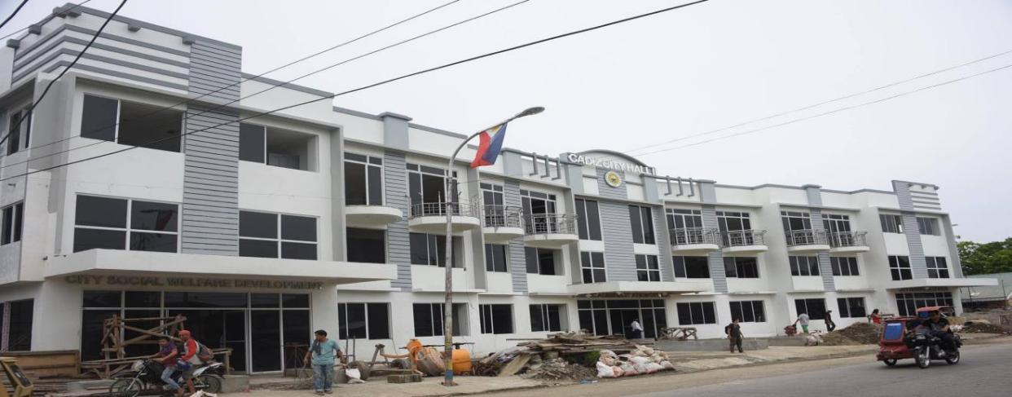
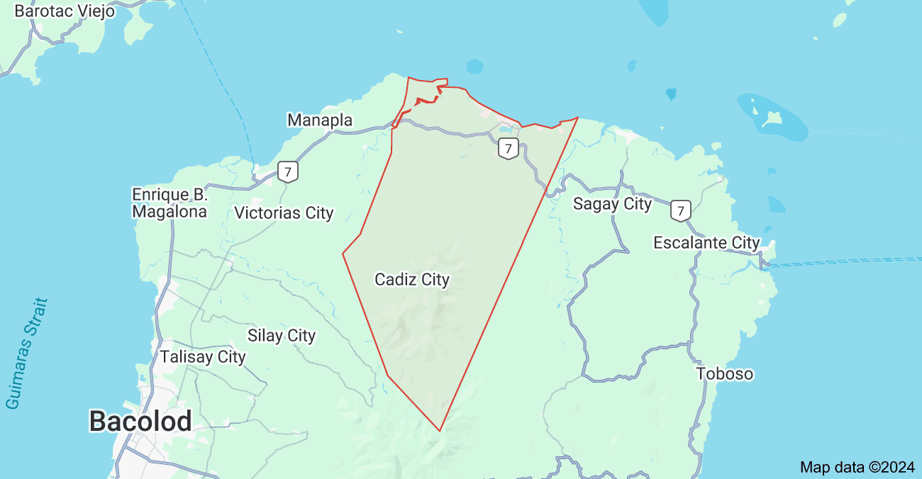
FIGURE 5: CADIZ CITY HALL II

FIGURE 4: CADIZ CITY MAP

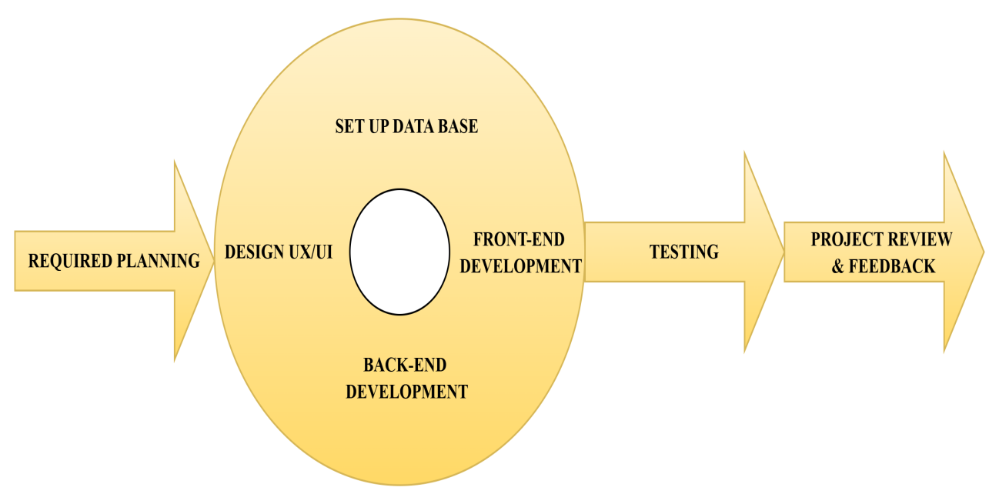
Theoretical Framework

FIGURE 6: The Theoretical Framework for Trackify: Personal Budget Tracker Mobile App

Rapid Application Development (RAD) model as the theoretical framework for the Trackify: Personal Budget Tracker Mobile App is a practical choice due to the model's focus on quick development cycles and adaptability. The RAD model is designed for projects requiring a swift development timeline and iterative refinement, which aligns well with the needs of a Budget Tracker Mobile App, where user feedback and evolving requirements can drive continuous improvements. RAD emphasizes prototyping and iterative development, allowing the team to quickly develop functional components of the finance app, gather user feedback, and adjust based on that feedback in a structured way. This approach also supports incremental improvements and testing, which helps ensure the app meets user expectations for tracking expenses, managing budgets, and monitoring financial goals efficiently.

Requirement Planning
This initial phase involves gathering all necessary requirements from stakeholders, including the target users. In this step, you define the app’s purpose, objectives, and scope, ensuring alignment with user needs, such as budget tracking, expense monitoring, and financial insights. Collaborating with stakeholders ensures that all functional and non-functional requirements, including usability and security, are well-documented before development begins.
Design UX/UI
During this phase, the team creates the user interface (UI) and user experience (UX) designs for the app. This includes wireframes, mockups, and prototypes to visualize the app’s layout and navigation. The focus is on simplicity and intuitiveness, ensuring that features like income tracking and budgeting are easily accessible. Feedback from potential users or stakeholders is crucial at this stage to refine the design.
Set Up Database
Here, the app’s back-end infrastructure is established by designing and configuring the database. The database will store critical information such as user income, expenses, and budget details. Special attention is given to ensuring data integrity and security. The database should be optimized for efficiency and scalability, considering the app’s long-term use.
Front-end Development
The front-end development phase involves translating the UX/UI designs into functional components. Developers create an interactive and responsive interface using appropriate technologies. This phase focuses on implementing features like logging income and expenses, generating financial reports, and setting budget goals. The aim is to ensure a seamless user experience across devices.
Back-end Development
In this phase, the back-end system is built to support the front-end functionality. This includes creating custom APIs for data interaction between the app and the database, implementing business logic for features like budget analysis, and integrating any third-party services, such as notification systems. Security measures, like encrypting sensitive data such as password, are also addressed here.
Testing
Once development is complete, the app undergoes rigorous testing. Functional, usability, and security tests are performed to identify and resolve issues. Testing ensures that all features work as intended, the interface is user-friendly, and the app is secure against potential vulnerabilities. End-user testing may also be conducted to gather real-world feedback.
Project Review and Feedback
In this final phase, the completed app is reviewed by stakeholders for quality assurance. Feedback from testing and stakeholder evaluation is used to refine the app further. Any necessary adjustments are made before deployment. This phase ensures that the app aligns with the initial objectives and meets user expectations.

Use Case Diagram
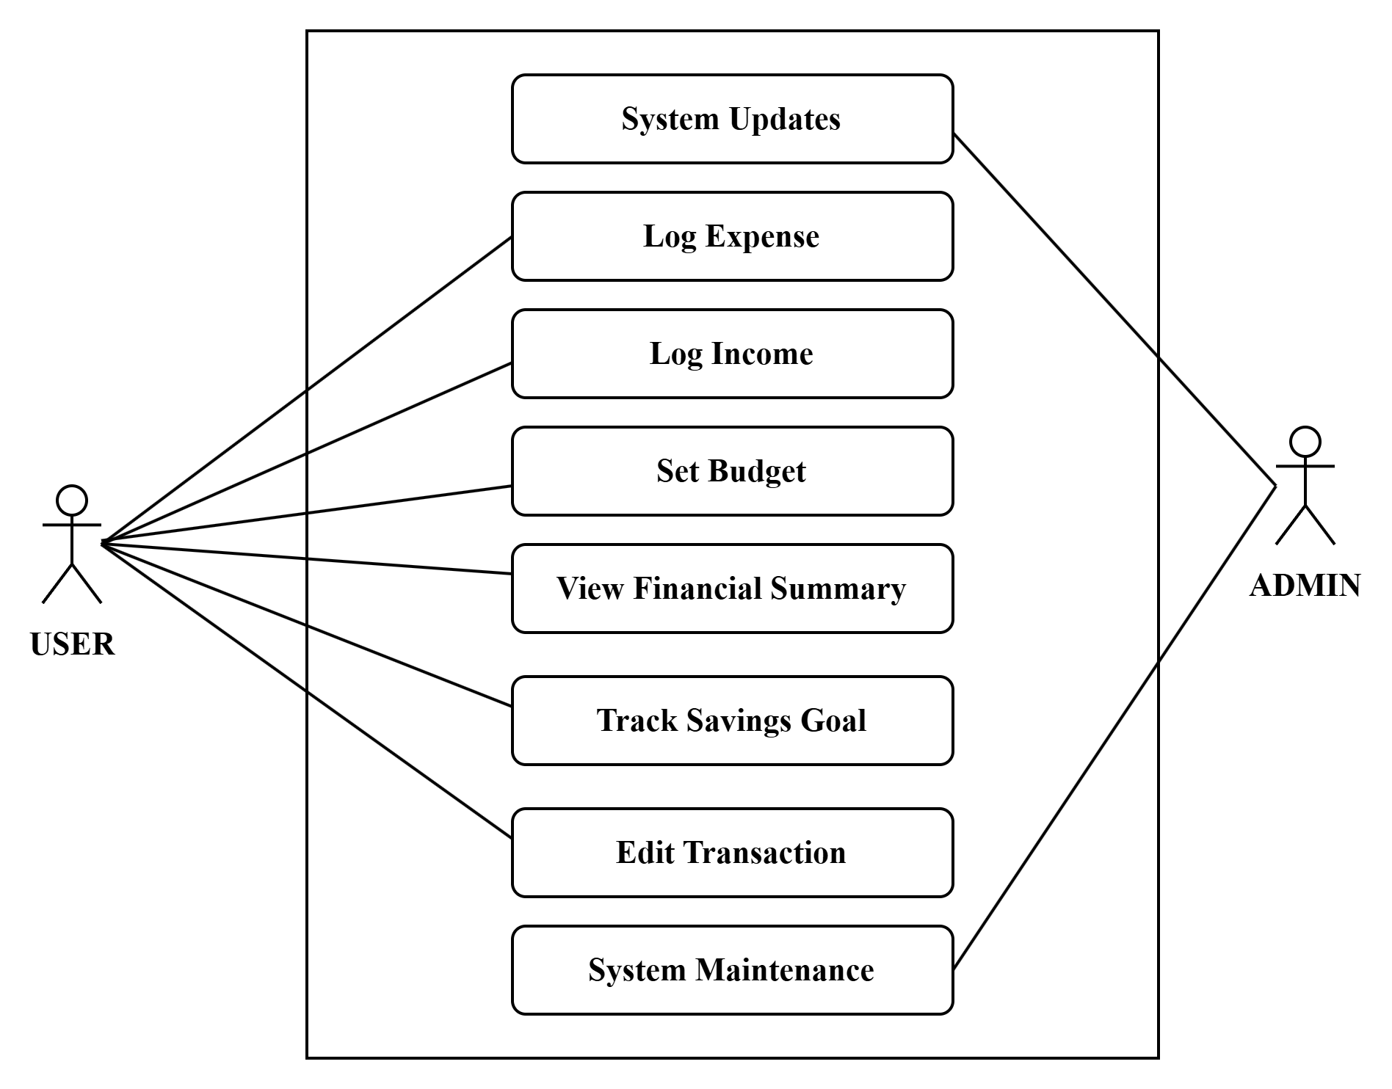

Requirement Costs
FIGURE 7: The Use Case Diagram for Trackify: Personal Budget Tracker Mobile App

Description (admin ) (user)
- MINIMUM HARDWARE REQUIREMENTS
- PC ₱18,690.00 ₱0
- CPU Type: Intel Core i5
- CPU Model: 12400
- Monitor ₱5,800.00 ₱0
- Dell SE2222H 22Inch Full HD (1080p)
- 1920 x 1080HDMI (HDCP 1.4) VGA Monitor
- Laptop ₱0 ₱32,000.00
- HP Laptop 15s-eq2xxx Processor
- AMD Ryzen 3 5300U with Radeon Graphics @ 2.60 GHz
- 1 Processor, 4 Cores, 8 Threads
8.00 GB DDR4 SDRAM 1597MHz
- Cellphone (Phone Tester) ₱0 ₱10,999.00
- Oppo A57
- Model CPH2387
- Processor
- Helio G35 Octa Core
- 128 GB Storage
- 6.56 in Screen Size
- 5000 mAh (TYP)
- 4.00 GB RAM
- Electricity ₱2,000.00 ₱1,000.00
- Keyboard and Mouse ₱550,00
- A4Tech KRS-8572 Usb2.0 119 × 62 × 37 mm
- Keyboard and Mouse Black
- SOFTWARE REQUIREMENTS
- Operating System (Windows 10 License) ₱10,000.00 ₱0
- Database Software (MySQL) ₱0 ₱0
- VS Code ₱0 ₱0
- Vector Graphics ₱0 ₱0
- Version Control (Github) ₱0 ₱0

III.NETWORK REQUIREMENTS
- High-Speed Internet (PLDT Fiber 150 Mbps) ₱1,399 ₱0
- LAN Setup (Ethernet cabling) ₱1,500.00 ₱0
- Network Security (Firewall & VPN) ₱0 ₱0
IV. INTEGRATION REQUIREMENTS
- Cloud Storage (Google Drive) ₱1,068.00 ₱0
TOTAL COST ₱47,108.00 ₱47,499.00

V. LABOR COST
Full Stack Developer ₱40,000
System Analyst ₱20,000
Visual Graphics ₱10,000
Maintenance ₱5,000

`

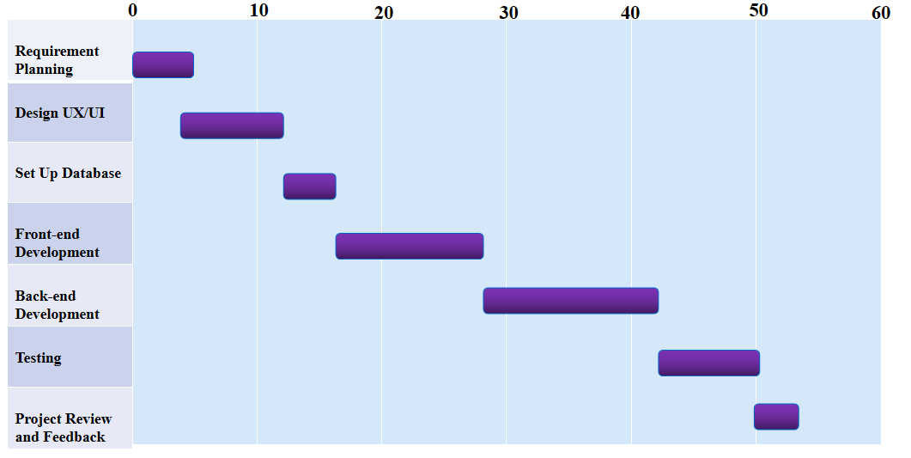
Gantt Chart
DURATION
(DAYS)
FIGURE 8: The Gantt Chart of the Work Flow of Trackify: Personal Budget Tracker Mobile App

System Prototype
MEDIUM FIDELITY PROTOTYPE OF TRACKIFY: PERSONAL BUDGET TRACKER MOBILE APP

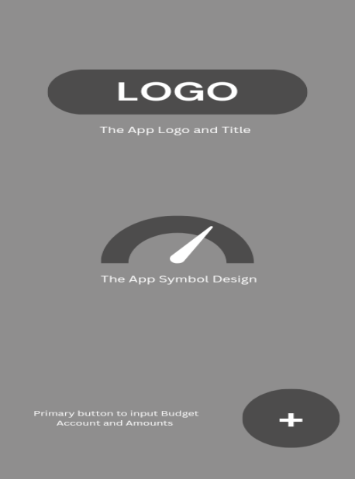

FIGURE 9:
First and font page of the App
FIGURE 10:
The primary page to create a Budget Account and respective amounts

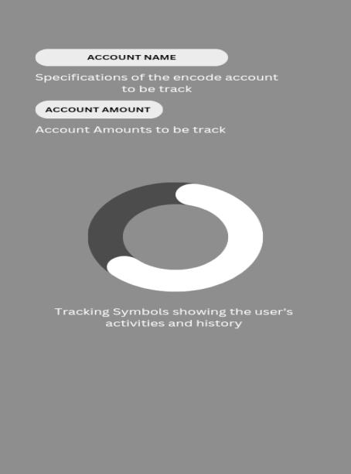
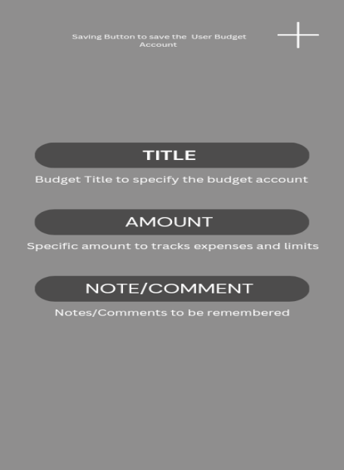
FIGURE 12:
The page where it shows the user’s activities and history
FIGURE 11:
The sections to specify the Budget name and last step to track the expenses
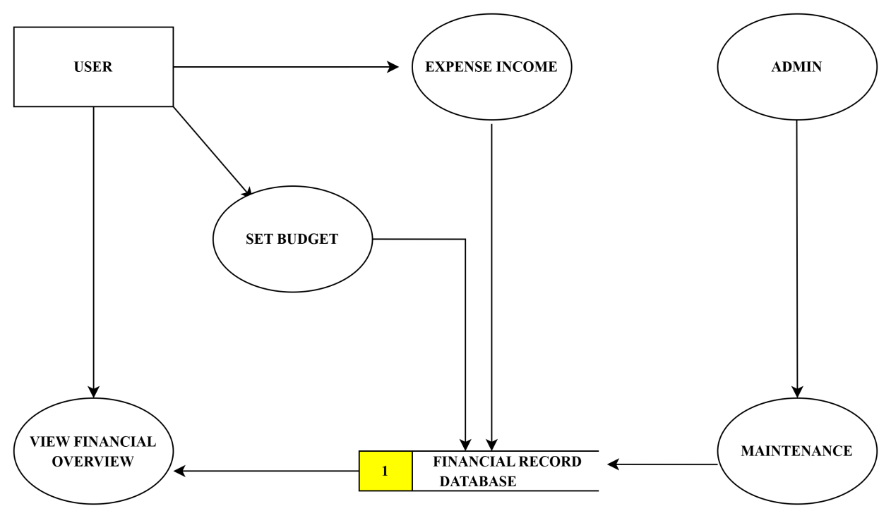
Data Flow Diagram

FIGURE 13: Data Flow Diagram

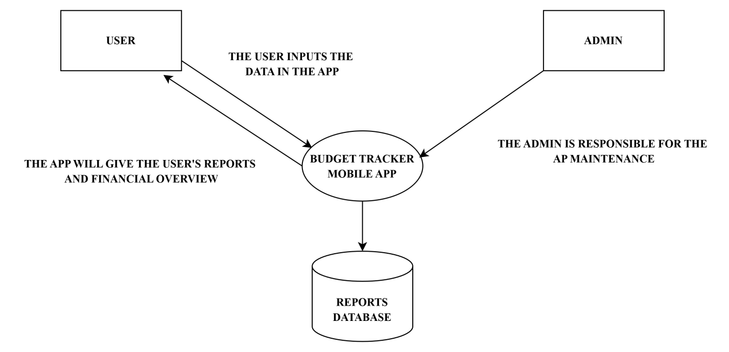
Data Flow Diagram Level 0

FIGURE 14: Data Flow Diagram Level 0
ER Diagram

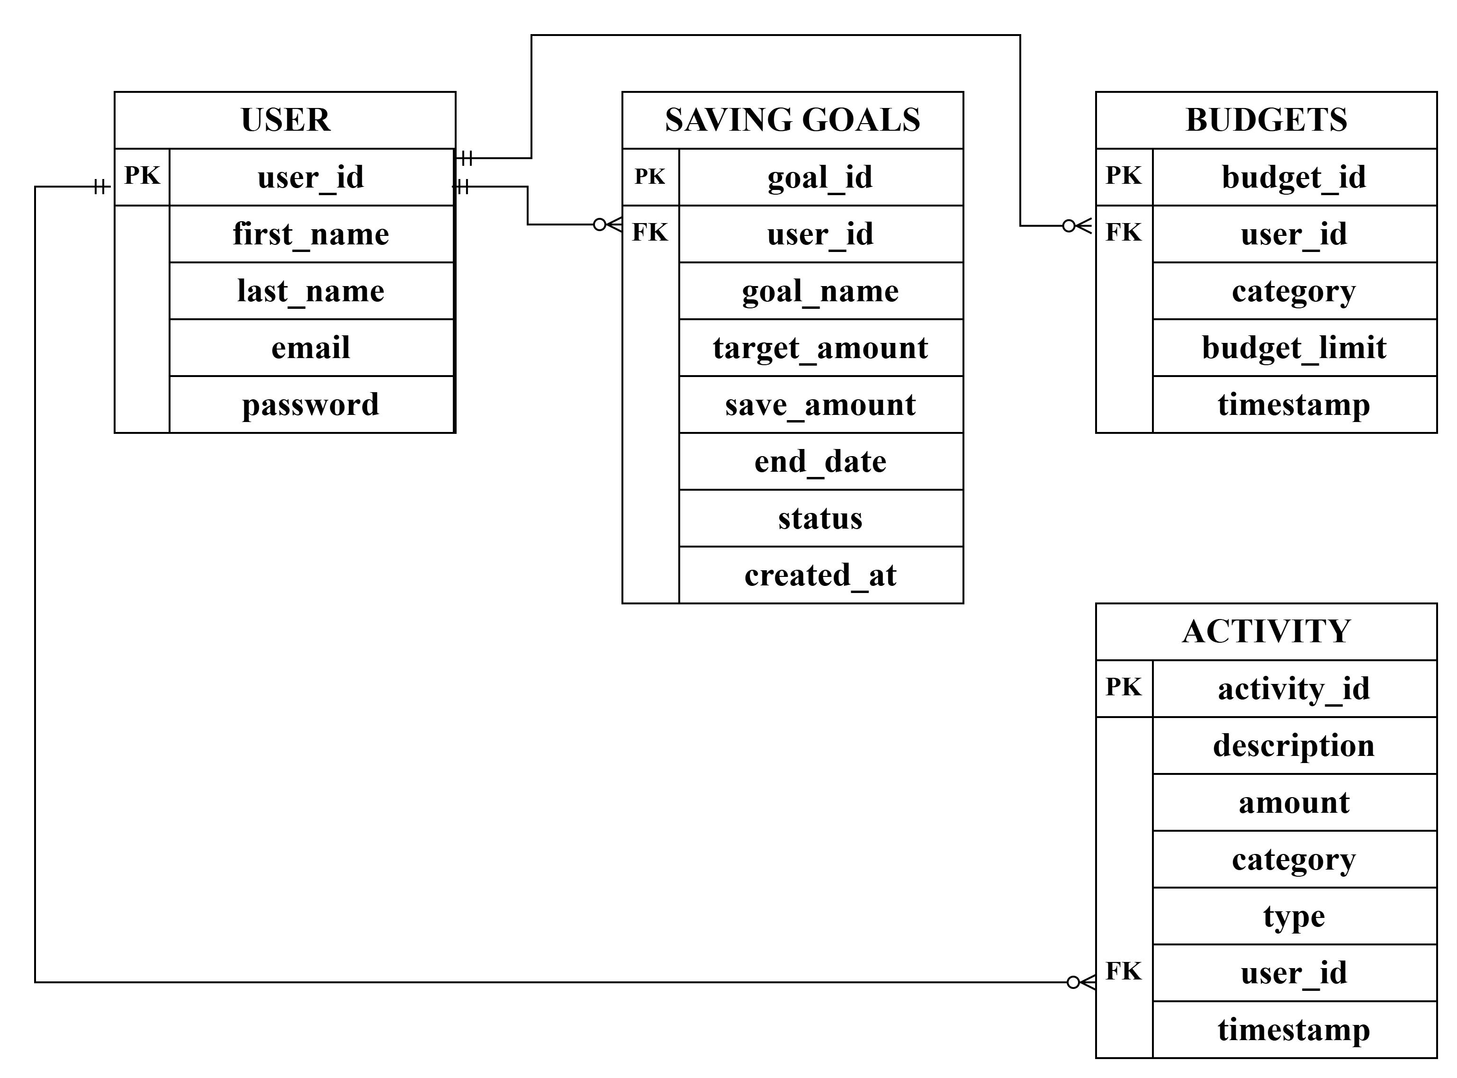

FIGURE 15: The Entity Relation Diagram of Trackify: Personal Budget Tracker Mobile App

System Architecture

The Trackify: Personal Budget Tracker Mobile App employs a Client-Server Architecture to ensure efficient data management, seamless user interaction, and secure operations. The architecture consists of three layers: the Client Layer, Server Layer, and Database Layer. The client layer includes two components: the User Client, representing the mobile app where users input financial data like transactions, income, and budgets, and retrieve outputs such as reports and summaries, and the Admin Client, which provides administrative capabilities for managing user accounts and monitoring the system.

The Server Layer serves as the core processing unit, handling critical operations such as tracking expenses and income, managing budgets, generating financial reports, and processing notifications like spending alerts and summaries. It acts as the intermediary between the clients and the database, ensuring all requests are processed securely and efficiently. The Database Layer uses MySQL to store essential data, including user transactions, budgets, and preferences. This layer ensures secure and reliable data storage and retrieval, supporting the app's functionality and maintaining data integrity.
This architecture allows for scalability, data security, and smooth interaction between users and the system, aligning with Trackify's goal of simplifying financial management and providing accurate insights. By separating responsibilities across distinct layers, the architecture ensures a cohesive workflow that supports the app’s objectives effectively.

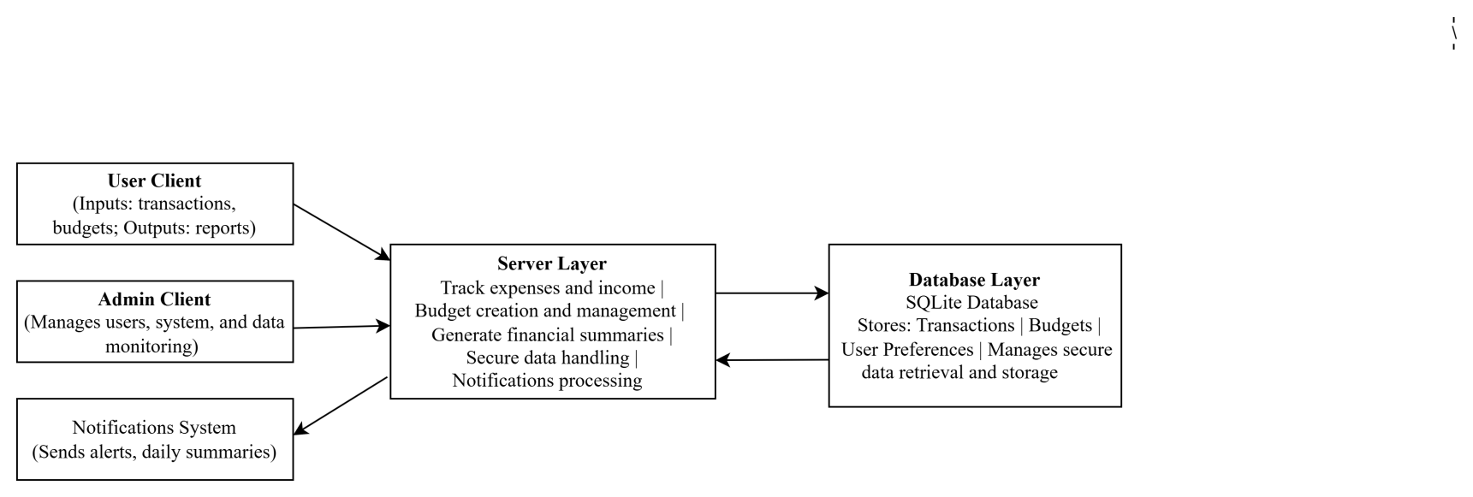

FIGURE 16: Client-Server Architecture
Program Evaluation and Review Technique

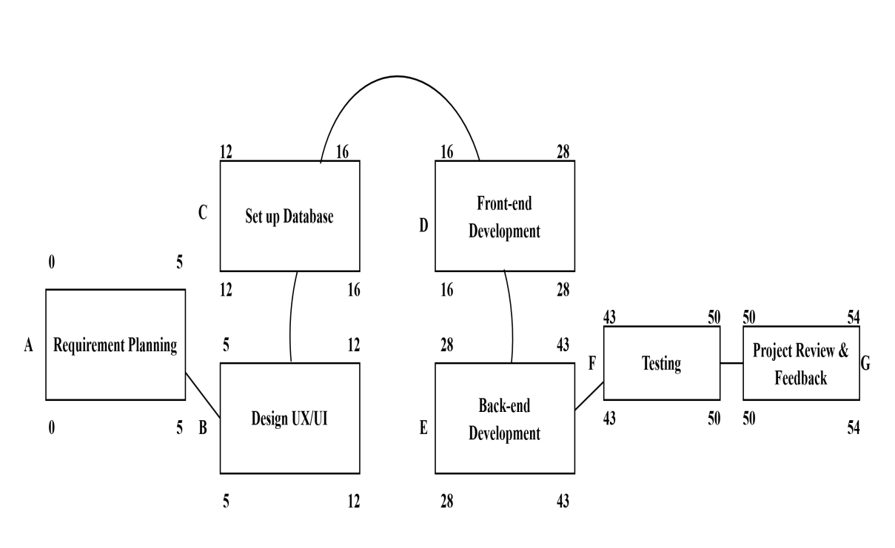

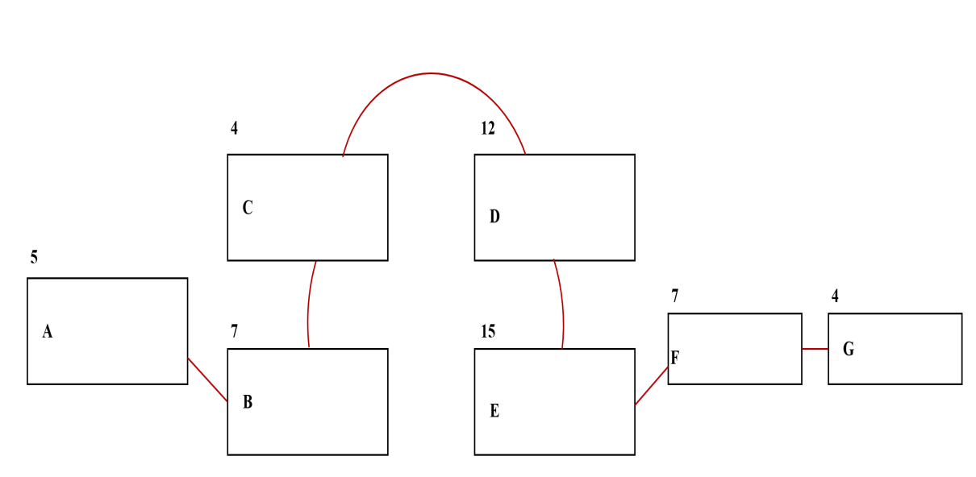
FIGURE 17: Program Evaluation and Review Technique

Critical Path Method

FIGURE 18: Critical Path Method

Total No. of Days = 54
Critical Path : A,B,C,D,E,F,G
COST BENEFIT ANALYSIS
Item | Year 0 | Year 1 | Year 2 | Year 3 | Year 4 | Total Cost | Total Benefits | Net Benefit/Cost
Development Cost | ₱155,506 | - | - | - |  | ₱155,506 | - | ₱155,506
Operational Cost | - | ₱19,000 | ₱19,000 | ₱19,000 | ₱19,000 | ₱72,000 | - | ₱72,000
Maintenance Cost | - | ₱10,000 | ₱10,000 | ₱10,000 | ₱10,000 | ₱40,000 | - | ₱40,000
TOTAL COST | ₱155,506 | ₱29,000 | ₱29,000 | ₱29,000 | ₱29,000 | ₱271,506 | -
PV Factor (10%) | 1.000 | 0.909 | 0.826 | 0.751 | 0.683 | - | - | -
Present Value | ₱155,506 | ₱26,361 | ₱23,954 | ₱21,779 | ₱19,807 | ₱247,407 | - | -
TOTAL BENEFITS | - | ₱80,000 | ₱90,000 | ₱100,000 | ₱110,000 |  | ₱380,000
PV Factor (10%) | 1.000 | 0.909 | 0.826 | 0.751 | 0.683 | - | - | -
Present Value | ₱0.00 | ₱72,720 | ₱74,340 | ₱75,100 | ₱75,130 |  | ₱297,290
Net Cash Flow | -₱155,506 | ₱46,359 | ₱50,386 | ₱53,321 | ₱55,323 |  | ₱49,883 | ₱49,883

FIGURE 19: The Cost Benefit Analysis

Return of Investment

Present Value Benefit ₱297,290
Present Value Cost ₱241,407

Formula for Calculating the ROI:
ROI%=$\left[\frac{Present Value − Initial Value}{Total Cost }\right]x 100$

ROI$=\left[\frac{Net Return}{Total Cost }\right]x 100$

ROI$=\left[\frac{₱297,290−₱241,407 }{₱241,407 }\right]x 100$

ROI$=\left[\frac{₱108,494}{₱241,407 }\right]x 100$

ROI$=\left[\frac{₱49,883}{₱241,407 }\right]x 100$

ROI$=0.20663443894x 100$

Return of Investments = 20.66%

CHAPTER III

Presentation of Data

Findings

FIGURE 20: Survey response on the perceived ease of navigating the app for first-time users.

As shown in the figure above, it reveals a strong positive perception of the app's user-friendliness. Out of the 15 respondents, 7 strongly agree that the app will be easy to navigate, while another 7 agree, showing that the majority (93%) anticipate a straightforward and intuitive interface. However, 1 respondent remains neutral, suggesting a level of uncertainty or hesitation regarding the app’s ease of use. Overall, the findings indicate that most participants believe the app will be accessible to new users, emphasizing the importance of focusing on simple and intuitive navigation during the development process. The neutral response may point to an opportunity for further refinements or communication to ensure clarity and confidence in the app’s design.
FIGURE 21: Survey response on the app being unnecessarily complicated for regular users.

As shown in the figure above, indicate varied perceptions among respondents. Of the 15 participants, 1 strongly agrees and 4 agree that the app might be unnecessarily complicated, representing 33% of the total responses. Conversely, 4 respondents disagree, suggesting confidence in the app’s simplicity, while the remaining 6 respondents are neutral, reflecting uncertainty or no strong opinion on the matter. This distribution highlights differing expectations about the app’s complexity among users.
FIGURE 22: Survey response on the integration of the app’s features for efficient financial tracking.

As shown in the figure above, out of 15 participants, 5 strongly agree, and 9 agree that the app’s features are expected to be well-integrated to support efficient financial tracking. Together, this accounts for 93% of respondents, showing confidence in the app's ability to integrate its functionalities effectively. Only 1 respondent remains neutral, suggesting minimal uncertainty about this aspect of the app.

FIGURE 23: Survey response on the time required to learn how to use the app effectively.

As shown in the figure above, show a diverse range of opinions among the 15 respondents. A total of 8 respondents (3 strongly disagree and 5 disagree) believe the app will not take much time to learn, indicating confidence in its ease of use. Meanwhile, 3 respondents are neutral, reflecting uncertainty or no strong opinion on the matter. On the other hand, 9 respondents (4 agree and 5 strongly agree) feel that the app might require more time to learn, suggesting that some users anticipate a learning curve.
FIGURE 24: Survey response on the app’s ability to help users manage finances more effectively than traditional methods.

As shown in the figure above, show a highly positive perception among respondents. Out of 15 participants, 8 strongly agree, and 4 agree, representing 80% of the total responses who believe the app will outperform traditional methods such as pen and paper. Meanwhile, 3 respondents are neutral, indicating some uncertainty but no disagreement. The absence of negative responses suggests strong confidence in the app’s potential to improve financial management for its users.

FIGURE 25: Survey response on the app’s layout and design potentially confusing users.

As shown in the figure above, the results indicate a mix of neutral and negative perceptions among the 15 respondents. A total of 7 respondents (47%) remain neutral, suggesting uncertainty about whether the app’s layout and design may be confusing. Additionally, 6 respondents (2 strongly disagree and 4 disagree) do not find the app’s layout potentially confusing, reflecting confidence in its clarity. However, 2 respondents agree, and none strongly agree, indicating minimal concern about the app’s layout. Overall, the responses suggest that most participants either perceive the design as non-confusing or are undecided.
FIGURE 26: Survey response on the app providing accurate calculations for budgets, income, and expenses.

The results demonstrate a highly positive perception among respondents. Out of 15 participants, 8 strongly agree, and 5 agree, representing 87% of the total responses, who believe the app will deliver accurate financial calculations. Only 2 respondents are neutral, and none disagree or strongly disagree, indicating no significant doubts about the app’s accuracy.
FIGURE 27: Survey response on the likelihood of frequent errors or bugs interfering with the app’s functionality.
The results show a predominantly neutral perception among respondents. Out of 15B participants, 8 (53%) remain neutral, indicating uncertainty about whether errors or bugs may interfere with the app’s functionality. Additionally, 4 respondents (2 strongly disagree and 2 disagree) believe that frequent errors or bugs are unlikely, suggesting some level of confidence in the app’s reliability. However, 3 respondents agree, and none strongly agree, indicating a small level of concern about potential issues. Overall, the responses suggest a mix of uncertainty and moderate confidence in the app’s stability.
FIGURE 29: Survey response on the app making financial record management simple and straightforward.

As shown in the figure above, reflect a highly positive perception among respondents. Out of 15 participants, 8 strongly agree, and 6 agree, representing a significant 93% of the total responses, who believe the app will simplify financial record management. Only 1 respondent remains neutral, and none disagree or strongly disagree, indicating no negative perceptions regarding this aspect of the app. These findings highlight strong confidence in the app's ability to make financial management easier and more accessible for users.

FIGURE 30: Survey response on the app meeting expectations for handling personal financial data securely.

As shown in the figure above, reveal a largely negative perception among respondents. Out of 15 participants, 8 (2 strongly disagree and 6 disagree) express doubts about the app's ability to meet expectations for securely handling personal financial data. Meanwhile, 4 respondents remain neutral, indicating uncertainty or lack of a strong opinion. Only 3 respondents (2 strongly agree and 1 agree) express confidence in the app’s data security.
Projections
1. Ease of Navigation
The overwhelmingly positive response (93%) suggests that most users will find the app intuitive and user-friendly upon deployment. The single neutral response indicates an opportunity to fine-tune the design, ensuring even clearer navigation pathways for all users.
2. Perceived Complexity
With 33% of respondents expressing concern that the app might be unnecessarily complicated, addressing this during the design phase is critical. Simplifying workflows and providing clear user guidance could reduce the perception of complexity and build confidence in the app’s usability.
3. Integration of Features
The 93% agreement on feature integration indicates strong user confidence in the app's ability to support efficient financial tracking. Maintaining seamless functionality and demonstrating integrated features during user onboarding will likely reinforce this positive perception.
4. Learning Curve
The mixed responses suggest a potential learning curve for some users, as 60% anticipate needing more time to familiarize themselves with the app. Incorporating onboarding tutorials and help features could mitigate this concern and ensure a smoother learning experience.
5. Effectiveness Over Traditional Methods
With 80% of respondents confident the app will outperform traditional methods, emphasizing these benefits in promotional materials will attract users. Addressing the uncertainties of the neutral respondents could further solidify the app’s perceived value.
6. Layout and Design Clarity
The mix of neutral and negative responses (47% neutral, 40% disagreeing) highlights the importance of refining the layout to avoid confusion. Testing the design with a broader audience could ensure clarity and reduce the potential for user misunderstandings.
7. Accuracy in Calculations
The strong positive perception (87%) regarding the app's accuracy reflects high user trust in its financial capabilities. Regular testing and validation of the app's calculations will be essential to maintain this trust and deliver on user expectations.
8. Reliability and Stability
With 53% neutral and 20% disagreeing, there is noticeable uncertainty regarding the app’s reliability. Focusing on robust testing to minimize bugs and showcasing the app’s stability during trials could convert neutral responses into positive ones.
9. Simplification of Financial Management
The overwhelmingly positive response (93%) suggests users believe the app will greatly simplify financial management. Highlighting this benefit in user communications will reinforce its value and attract more users.
10. Data Security Concerns
The largely negative response (53% disagreeing or strongly disagreeing) signals significant concerns about data security. Prioritizing secure handling of financial information and transparently communicating these measures to users will be critical to gaining trust and confidence.

Based on the findings and projections, the Trackify: Personal Budget Tracker Mobile App shows strong potential to meet user expectations in ease of navigation, feature integration, and simplifying financial management. However, areas like perceived complexity, data security, and reliability need attention. To address these, the development team should streamline workflows, incorporate onboarding tutorials, and ensure intuitive design to make the app accessible to all users. Security can be enhanced by implementing a lockout system after failed login attempts and educating users on securing their devices with strong PINs or biometrics. Emphasizing the app’s strengths in simplifying financial tasks and providing accurate calculations in marketing strategies will build trust and user engagement, establishing Trackify as a reliable and user-friendly financial tool.
CHAPTER IV
CONCLUSION AND RECOMMENDATION

The Trackify: Personal Budget Tracker Mobile App is designed to address the growing need for efficient and accessible financial management tools. This app aims to simplify the process of tracking income, expenses, and budgets while providing users with actionable insights into their financial health. To ensure the app meets user expectations and delivers an optimal user experience, the System Usability Scale (SUS) method was employed as the primary tool for evaluating usability. The SUS method, a reliable and widely used framework, provides a quantitative measure of usability through a 10-item questionnaire, helping identify areas of strength and improvement.
By utilizing the SUS method, the project gathered essential feedback on aspects such as ease of navigation, feature integration, and overall user satisfaction. This data informed the development process, ensuring that Trackify aligns with user needs while addressing challenges like perceived complexity and data security. The results and insights gained from this approach provide a strong foundation for refining the app and achieving its goal of empowering users to manage their finances effectively and confidently.

Conclusion
The findings from this study demonstrate that the Trackify: Personal Budget Tracker Mobile App aligns well with its objectives of simplifying financial management, providing accurate calculations, and supporting effective personal finance tracking. With an overall SUS score of 70.17, rated as "Good," the app is perceived as usable by most respondents. The study reveals that users value the app’s ease of navigation, feature integration, and its ability to simplify financial record management. These findings
directly address the statement of the problem, confirming the app’s potential to serve as a tool for improving personal financial habits and tracking expenses efficiently.
However, the results also highlight areas needing improvement, particularly in addressing perceived complexity, security concerns, and user confidence in its reliability. These challenges align with the study’s objective of ensuring that the app meets user expectations while safeguarding sensitive financial data. Addressing these issues by refining workflows, enhancing security protocols, and implementing user-friendly design solutions will further strengthen the app’s usability and trustworthiness. By building on these findings, the Trackify: Personal Budget Tracker Mobile App can achieve its goal of providing a comprehensive, secure, and accessible financial management tool for its target audience.
Recommendation
Based on the entirety of this study, the development of the Trackify: Personal Budget Tracker Mobile App should prioritize aligning its features and design with the objectives and problem statements outlined. The findings demonstrate the importance of creating a tool that is not only functional but also user-centric. To achieve this, it is recommended that the development team implement iterative usability testing throughout the design and development process. This ensures that user feedback is continuously integrated, addressing concerns about perceived complexity, security, and reliability while maintaining the app's strengths, such as its ease of navigation and accurate financial calculations.
Additionally, the app’s educational and onboarding materials should be enhanced to mitigate the learning curve for new users. Interactive tutorials, tooltips, and user guides can support a smoother user experience, especially for individuals with limited technical knowledge. Moreover, data security measures must be robust and clearly communicated to users. Implementing secure
data storage, such as local encryption techniques, and reinforcing this through user education will help alleviate concerns about handling sensitive financial data.
Finally, to maximize the app’s impact and reach, strategic efforts should focus on effectively marketing its strengths, particularly its ability to simplify financial management and provide reliable calculations. Combining these efforts with a transparent communication strategy about future updates and improvements will ensure continued user engagement and satisfaction. By addressing these recommendations, the Trackify: Personal Budget Tracker Mobile App can establish itself as a reliable and indispensable tool for personal financial management.

REFERENCES
- Althea Grace, D., Valerie Mae, R., & Lazaro Bryan Louis, G.(2024) Navigating Financial
Struggle: The Ripple Effect of Inflation Rates on Working Students. International Journal of Advanced Multidisciplinary Research and Studies.
Retrieved from:
https://www.multiresearchjournal.com/admin/uploads/archives/archive-1717745840.pdf
Date Accessed: September 13, 2024
- Anoos, J., Ferrater-Gimena, J. A. O., Etcuban, J. O., Dinauanao, A. M., Macugay, P. J. D. R., & Velita, L. V. (2020). Financial management of micro, small, and medium enterprises in Cebu, Philippines. International Journal of Small Business and Entrepreneurship Research, 8(1), 53-76.
Retrieved from: https://www.academia.edu/download/62786673/Etcuban_et_al-article20200403-34771-1ml0vd0.pdf
Date Accessed: September 13, 2024
- Capucao, J. N., Palaoag, T., & Sierra, S. (2020). Web-based System for State Universities and Colleges Budget Office Management. In IOP Conference Series: Materials Science and Engineering. IOP Publishing. (Vol. 803, No. 1, p. 012009).
Retrieved from:
https://iopscience.iop.org/article/10.1088/1757899X/803/1/012009/pdf
Date Accessed: September 13, 2024
- Gamst-Klaussen, T., Steel, P., & Svartdal, F. (2019). Procrastination and personal finances: Exploring the roles of planning and financial self-efficacy. Frontiers in psychology, 10, 442909.
Retrieved from: https://www.frontiersin.org/articles/10.3389/fpsyg.2019.00775/full?
ref=finex.blog
Date Accessed: September 13, 2024
- Garcia, M. B., & Claour, J. P. (2021). Mobile bookkeeper: personal financial management application with receipt scanner using optical character recognition. In 2021 1st Conference on Online Teaching for Mobile Education (OT4ME) (pp. 15-20). IEEE.
Retrieved from: https://manuelgarcia.info/media/full_paper/mobilebookkeeper.pdf
Date Accessed: September 13, 2024
- Jabar, M. A., & Delayco, M. L. C. (2021). Impulse Buying and Financial Literacy Among Public Elementary and High School Teachers in the Philippines. DLSU Business & Economics Review, 31(1).b
Retrieved from:
https://www.dlsu.edu.ph/wpcontent/uploads/2021/08/DLSUBER.2021.July_.4jabpdf
Date Accessed: September 13, 2024
- Masood, R., Berkovsky, S., & Kaafar, M. A. (2022). Tracking and Personalization
Retrieved from:
https://library.oapen.org/bitstream/handle/20.500.12657/52825/978-3-030-
82786-1.pdf?sequence=1#page=174
Date Accessed: September 13, 2024
- Sooriyakumaran, L., Thrikawala, S. S., & Pathirawasam, C. (2022). A study between the association of financial management practices and performance of small and medium enterprises (SMEs) background: A working paper. International Journal of Research and Innovation in Social Science, 6(1), 166-179.
Retrieved from:
https://www.researchgate.net/profile/Logeswary-Sooriyakumaran 2/publication/358808011_IJRISS_Volume_VI_Issue_I/links/6216cb754ef2165938ef112c /IJRISS-Volume-VI-Issue-I.pdf
Date Accessed: September 13, 2024

- Samar Verma, Samarjeet Singh Kheda, & Shivam Kuwale (2024) Personal Finance Tracker. International Research Journal of Modernization in Engineering Technology and Science Volume:06
Retrieved from:
https://www.irjmets.com/uploadedfiles/paper//issue_5_may_2024/58377
/final/fin_irjmets1717316478.pdf
Date Accessed: September 13, 2024
- Zhavoronok, A., Popelo, O., Shchur, R., Ostrovska, N., & Kordzaia, N. (2022). The role of digital technologies in the transformation of regional models of households’ financial behavior in the conditions of the national innovative economy development. Ingenierie des Systemes d'Information, 27(4), 613.
Retrieved from:
https://www.researchgate.net/profile/ArturZhavoronok/publication/363770960.pdf
Date Accessed: September 13, 2024

APPENDIX A

LETTER OF PERMISSION
January 25, 2025

CEDAR College, Inc.
National Highway, Cadiz City, Negros Occidental

PERMISSION LETTER

Dear Mr. Lobaton,

We hope this letter finds you well. We are Aireen F. Deocampo, John Philip M. Villa, Yasmin Alito Pescadero and Nel Mayer M. Tibor, a group of four students from Cedar College, Inc. currently working on our capstone project, Trackify: Personal Budget Tracker Mobile App.

We request permission to conduct a testing phase with an IT industry expert to assess the app’s functionality, usability, reliability, performance, and security. The tester’s insights will help refine the app and ensure it meets its intended objectives.

This testing will not involve additional participants and will solely rely on the expert’s evaluation. All gathered data will be used strictly for academic purposes and will remain confidential.
We appreciate your support in this process and look forward to your approval. Should you need further details, please feel free to contact us.

Sincerely,
THE PROJECT TEAM

Aireen. F. Deocampo John Philip M. Villa
aireendeocampo536@gmail.com mcityjr420@gmail.com
09637572392 09636179828

Yasmin A. Pescadero Nel Mayer Maningo Tibor
pescaderoyasmin@gmail.com Tibornelmayer2@gmail.com
09277163445 09065187092

Approved by: JOHN DAVE BARILEA ROMEO D. LOBATON
IT Instructor Tech Squad Solution

Feb 2 , 2025

CEDAR College, Inc.
National Highway, Cadiz City, Negros Occidental

PERMISSION LETTER

Dear Mr. Hermoso,

We hope this letter finds you well. We are Aireen F. Deocampo, John Philip M. Villa, Yasmin Alito Pescadero and Nel Mayer M. Tibor, a group of four students from Cedar College, Inc. currently working on our capstone project, Trackify: Personal Budget Tracker Mobile App.

We request permission to conduct a testing phase with an IT industry expert to assess the app’s functionality, usability, reliability, performance, and security. The tester’s insights will help refine the app and ensure it meets its intended objectives.

This testing will not involve additional participants and will solely rely on the expert’s evaluation. All gathered data will be used strictly for academic purposes and will remain confidential.
We appreciate your support in this process and look forward to your approval. Should you need further details, please feel free to contact us.

Sincerely,
THE PROJECT TEAM

Aireen. F. Deocampo John Philip M. Villa
aireendeocampo536@gmail.com mcityjr420@gmail.com
09637572392 09636179828

Yasmin A. Pescadero Nel Mayer Maningo Tibor
pescaderoyasmin@gmail.com Tibornelmayer2@gmail.com
09277163445 09065187092

Approved by: JOHN DAVE BARILEA RAYMUND ALORIA HERMOSO
IT Instructor App Developer

Feb 3, 2025

CEDAR College, Inc.
National Highway, Cadiz City, Negros Occidental

PERMISSION LETTER

Dear Mr. Arroyo,

We hope this letter finds you well. We are Aireen F. Deocampo, John Philip M. Villa, Yasmin Alito Pescadero and Nel Mayer M. Tibor, a group of four students from Cedar College, Inc. currently working on our capstone project, Trackify: Personal Budget Tracker Mobile App.

We request permission to conduct a testing phase with an IT industry expert to assess the app’s functionality, usability, reliability, performance, and security. The tester’s insights will help refine the app and ensure it meets its intended objectives.

This testing will not involve additional participants and will solely rely on the expert’s evaluation. All gathered data will be used strictly for academic purposes and will remain confidential.
We appreciate your support in this process and look forward to your approval. Should you need further details, please feel free to contact us.

Sincerely,
THE PROJECT TEAM

Aireen. F. Deocampo John Philip M. Villa
aireendeocampo536@gmail.com mcityjr420@gmail.com
09637572392 09636179828

Yasmin A. Pescadero Nel Mayer Maningo Tibor
pescaderoyasmin@gmail.com Tibornelmayer2@gmail.com
09277163445 09065187092

Approved by: JOHN DAVE BARILEA REY S. ARROYO
IT Instructor Teacher

Aireen F. Deocampo
Sitio Besang Brgy. Luna Cadiz City Negros Occidental
Cadiz City, Negros Occidental, 6121
aireendeocampo536@gmail.com
09637572392

September 13, 2024

John Rey Bela Ong
Client Support Specialist
Global Strategic
Vic Arcade Building, Ground Floor, Osmenia Avenu
Brgy. 1,Victorias City Negros Occidental

Subject: Appreciation and Acknowledgment for Participation in Test Survey
Dear Mr Bela Ong,
On behalf of our capstone project team, we would like to express our sincere gratitude for your time and valuable insights during our test survey for "Trackify: Personal Budget Tracker Mobile App." Your participation and honest feedback have been instrumental in assessing and improving our system.
We truly appreciate the effort you took to evaluate our project and provide constructive comments. Your expertise and perspective have greatly contributed to refining our application, ensuring it is user-friendly, efficient, and aligned with the needs of our target users.
The positive remarks and high ratings we received, along with your helpful suggestions, will guide us in further enhancing our system before its final implementation. Your support means a lot to our team, and we are thankful for the opportunity to collaborate with you.
Once again, we extend our heartfelt appreciation for your time and assistance. We look forward to sharing the final outcome of our project with you in the near future.
Sincerely,
THE PROJECT TEAM

Aireen. F. Deocampo John Philip M. Villa
aireendeocampo536@gmail.com mcityjr420@gmail.com
09637572392 09636179828

Yasmin A. Pescadero Nel Mayer Maningo Tibor
pescaderoyasmin@gmail.com Tibornelmayer2@gmail.com
09277163445 09065187092

APPENDIX B

CAPSTONE PROJECT

SURVEY QUESTIONNAIRE RATING SHEET

Project Title: TRACKIFY: PERSONAL BUDGET TRACKER MOBILE APP.
Survey Date: January 25, 2025
Name (leave blank if anonymous):
Please rate each statement based on your level of preference using the scale provided. This feedback will help the development team understand the requirements and expectations for developing their IT Capstone Project.

Encircle

Rating Scale:
1 – Strongly Disagree
2 – Disagree
3 – Neutral
4 – Agree
5 – Strongly Agree

CLARITY / RELEVANCE OF SURVEY QUESTIONS
1. The questions are clear and easy to understand. | 5 | 4 | 3 | 2 | 1
2. The questions are relevant to the goals of the requirements gathering. | 5 | 4 | 3 | 2 | 1
3. The questions avoid technical jargon or complex terminology. | 5 | 4 | 3 | 2 | 1
4. The survey flow is easy to follow. | 5 | 4 | 3 | 2 | 1
5. Each question directly relates to gathering project requirements. | 5 | 4 | 3 | 2 | 1
QUESTION VARIETY AND DEPTH
1. The survey includes a good mix of  question types (such as: multiple choices, rating scales, open-ended questions). | 5 | 4 | 3 | 2 | 1
2. The survey covers all major aspects of the system requirements (such as functional and non-functional requirements). | 5 | 4 | 3 | 2 | 1
3. The questions explore the needs and  expectations of the users in detail. | 5 | 4 | 3 | 2 | 1
4. The survey includes questions that encourage useful feedback. | 5 | 4 | 3 | 2 | 1
5. The length of the survey is appropriate and not too long. | 5 | 4 | 3 | 2 | 1
ALIGNMENT WITH PROJECT GOALS
1. The survey is aligned with the overall  objectives of the capstone project. | 5 | 4 | 3 | 2 | 1
2. The questions help identify the critical system requirements for development. | 5 | 4 | 3 | 2 | 1
3. The survey is effective in identifying the  needs and pain points of the end-user. | 5 | 4 | 3 | 2 | 1
4. The survey questions support gathering  non-functional requirements (such as  performance/security of the system) | 5 | 4 | 3 | 2 | 1
5. The survey facilitates gathering  information about the desired features. | 5 | 4 | 3 | 2 | 1
USER ENGAGEMENT AND ACCESSIBILITY
1. The survey is user-friendly and engaging for participants. | 5 | 4 | 3 | 2 | 1
2. The language used in the survey is  understood by the participants. | 5 | 4 | 3 | 2 | 1
3. The survey encourages honest responses. | 5 | 4 | 3 | 2 | 1
4. The survey instructions are clear. | 5 | 4 | 3 | 2 | 1
5. The survey includes sufficient options for respondents to provide feedback. | 5 | 4 | 3 | 2 | 1
OVERALL EFFECTIVENESS AND SUGGESTIONS
1. The survey, in terms of gathering the necessary requirements, is effective in general. | 5 | 4 | 3 | 2 | 1
2. The survey will likely yield or produce  good insights for the project team. | 5 | 4 | 3 | 2 | 1
3. The survey is able to freely obtain  suggestions for the participants. | 5 | 4 | 3 | 2 | 1

Average Score:
(To compute for the Average Score, add all the values encircled, and then divide the sum by 23.)
Additional Comments (thoughts on how to improve the survey questionnaire):

APPENDIX C

SURVEY QUESTIONNAIRE


CEDAR College, Inc.
National Highway Cadiz City, Negros Occidental
RESEARCH INSTRUMENT EVALUATION FORM

Name of Respondent (Optional):________________________________________

Directions:
Thank you for dedicating your time to participate in this survey. Your valuable input will significantly contribute to the development of our Trackify: Personal Budget Tracker Mobile App

Please carefully read each question and provide your answers based on your personal financial habits, goals, and app feature preferences. For scaled questions, kindly indicate your response by selecting the number that best reflects your opinion and marking it in the appropriate box.

We assure you that all responses will remain confidential and will be used exclusively for academic research purposes. If you have any questions or concerns about this survey, please do not hesitate to contact us at 09637573392 or via email at aireendeocampo536@gmail.com.
We deeply appreciate your participation and insights, which will help us design an app tailored to the financial needs of our community.

[Please proceed to answer the questionnaire below.]

 | (5)  Strongly agree | (4)  Agree | (3)  Neutral | (2)  Disagree | (1)  Strongly disagree
- I believe the app will be easy to navigate, even for first-time users.
- I expect the app to be unnecessarily complicated for regular users.
- The app’s features will be well-integrated and allow me to perform financial tracking tasks efficiently.
- I believe it will take too much time to learn how to use the app effectively.
- I expect the app to help me manage my finances more effectively than traditional methods (e.g., pen and paper).
- The app’s layout and design might confuse users, making it difficult to find key features.
- I believe the app will provide accurate calculations for budgets, income, and expenses.
- I expect frequent errors or bugs to interfere with the app's functionality.
- The app will make managing my financial records simple and straightforward.
- The app might not meet my expectations for handling personal financial data securely.
User Acceptance Test (UAT) Rating Sheet
This User Acceptance Test (UAT) rating sheet gathers feedback on the Trackify: Personal Budget Tracker Mobile App using the ISO 25010 software quality model. The ratings are for evaluation purposes only and do not guarantee final performance, reliability, or compliance. The results will be used to guide future improvements and may vary based on user experience.
Please read each statement carefully and rate your experience using the following scale:
1 – Poor (Needs significant improvement)
2 – Fair (Somewhat functional but requires enhancements)
3 – Good (Meets expectations with minor improvements needed)
4 – Very Good (Performs well with only slight issues)
5 – Excellent (Fully meets expectations with no issues)
Kindly select the rating that best reflects your assessment by marking the appropriate number. Your responses will remain confidential and will be used solely for research and development purposes. Thank you for your time and valuable insights.
Evaluation Criteria:
Criteria | Poor  1 | Fair  2 | Good  3 | Very Good  4 | Excellent  5
FUNCTIONALITY
- How well does the app allow you to log income, expenses, and budgets accurately and efficiently?
- How effectively does the app generate financial summaries and reports that are easy to understand?
- How well does the app help in tracking and managing financial transactions over time?
USABILITY
- How would you rate the app’s user-friendliness, including navigation and intuitive design?
- How sufficient are the app’s guidance and instructions, such as onboarding tutorials, for new users?
- How easy is it to access and use the app’s key features without confusion?
RELIABILITY
- How stable is the app in terms of being free from crashes or major glitches during use?

- How consistently does the app save and retrieve data without errors?
- How reliable is the app in maintaining data accuracy over time?
PERFORMANCE
- How responsive is the app when performing actions such as logging transactions or generating reports?
- How quickly does the app process and display financial data?
- How well does the app perform without lag or delays?
COMPATIBILITY
- How well does the app function across various Android devices, regardless of model or specifications?
- How effectively does the app adapt to different screen sizes and resolutions?
- How well does the app integrate with other mobile system features (e.g., notifications, storage)?
SECURITY
- How effective is the login authentication in protecting access to the app?
- How secure do you feel about the app’s ability to store and protect your financial data?
- How well does the app prevent unauthorized access or data breaches?

Feedback Section:
- Comments: ____________________________________________________________________
- Suggestions: ____________________________________________________________________

APPENDIX D

CERTIFICATE OF GRAMMARIAN

CEDAR COLLEGE, INC.
National Highway, Cadiz City Negros Occidental

GRAMMARIAN CERTIFICATE

This is to certify that the undersigned has viewed and went through all the pages of the Capstone Project entitled "TRACKIFY: PERSONAL BUDGET TRACKER MOBILE APP" developed by AIREEN DEOCAMPO, JOHN PHILIP VILLA, NEL MAYER TIBOR, YASMIN PESCADERO aligned with the set of structural rules that govern the composition of sentences, phrases and words in the English Language.

Signed this 3rd day of March, 2025 at Cadiz City Negros Occidental.

FLORA MAY M. TIBOR
CAR (Complete Academic Requirement)

APPENDIX E
SOURCE CODE

APPENDIX F

USER MANUAL FOR TRACKIFY: TRACKIFY: PERSONAL BUDGET TRACKER MOBILE APP
BY: GROUPWAN

Introduction
Welcome to TRACKIFY: PERSONAL BUDGET TRACKER MOBILE APP! This application is designed to help you manage your expenses, track your income, and set budget goals efficiently. With its intuitive interface, TRACKIFY: PERSONAL BUDGET TRACKER MOBILE APP simplifies financial planning and helps you gain better control over your money.

System Requirements:
(Hardware Requirements):
- Smartphone (Android)

Installation Guide
For Android Users:
1. Open the Google Play Store.
2. Search for Trackify: Personal Budget Tracker Mobile App
3. Tap Install and wait for the download to complete.
4. Once installed, tap Open to launch the app.

Post-Installation Setup

1. Create an Account – Sign up using your email and add activity.
2. Set Monthly Budget – Customize your budget categories (e.g., food, bills, savings).
3. Enable Notifications – Receive alerts for budget limits, bill reminders, and expense updates.

User Interface Walk-through
Main Dashboard:
- Displays your total balance, expenses, and income summary.
- Quick-access buttons for adding new transactions.
Transactions Tab
- View, edit, and categorize income and expenses.
- Filter transactions by date, category, or amount.
Budget Section
- Set spending limits for different categories.
Reports & Insights
- Generate spending reports for weekly, monthly, or custom periods.
- View trends and savings insights.
Settings Menu
- Manage account details
- Enable darkmode

Common Use Cases
1. Adding an Expense:
Tap the add activity button on the main dashboard.•
- Enter amount, category, and description.
- Click Save to log the transaction.
2. Setting a Budget:
- Navigate to the Budget tab.
- Select a category (e.g., bills, food, shopping).
- Set a limit and enable alerts for overspending.

Troubleshooting & FAQs
1. Unable to log in?
- Check your internet connection.
- Make sure to double check your credentials.

APPENDIX G

CURRICULUM VITAE

